Questions

**ISM - EC2 - MidSem**

# **Module 1: Basic Probability & Statisitcs**

## **CS 1 - Measures of Central Tendency & Measures of Variability, Data – Symmetric & Asymmetric, outlier detection, 5 point summary, Introduction to probability**

**Question Papers**

**2022-2023 (28th Jan 2023) MidSem (Makeup) (DSE)**

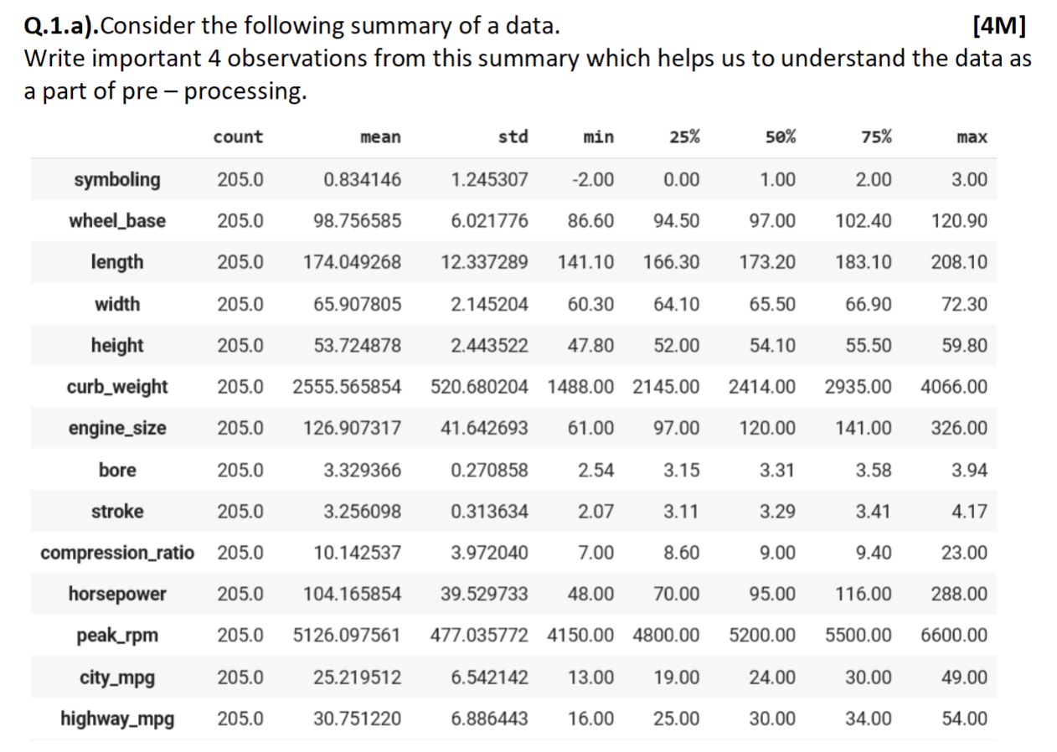

**2022-2023 (8th Jan 2023) MidSem (Regular) (DSE)**

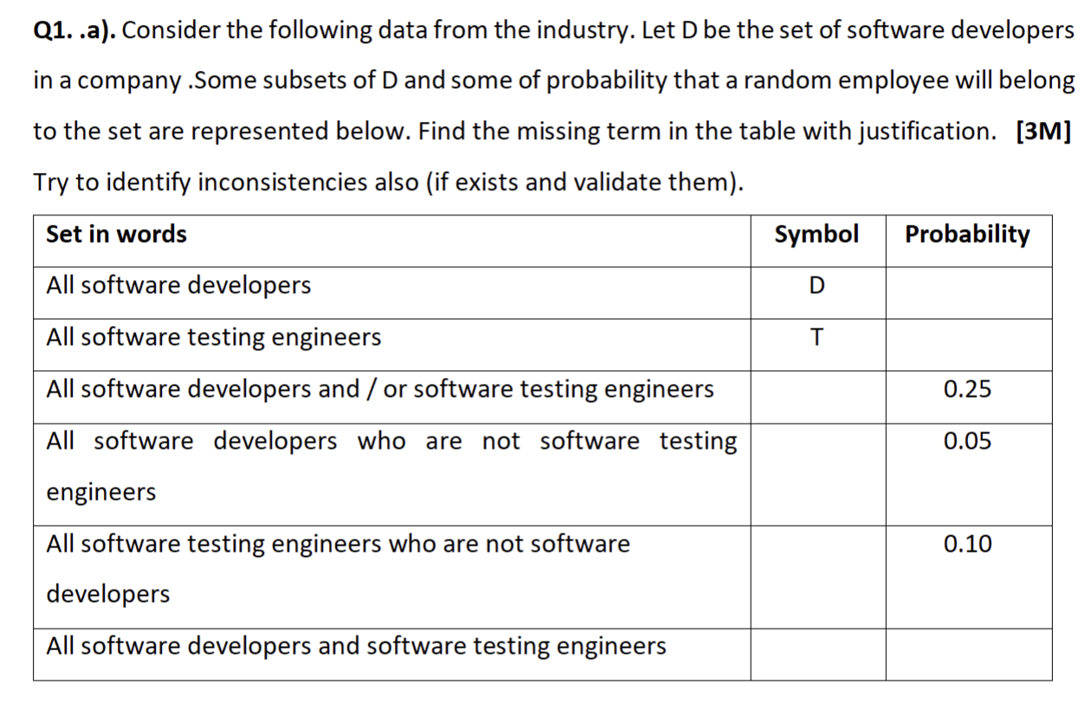

**2022-2023 (16th July 2023) MidSem (Regular) (AI&ML)**

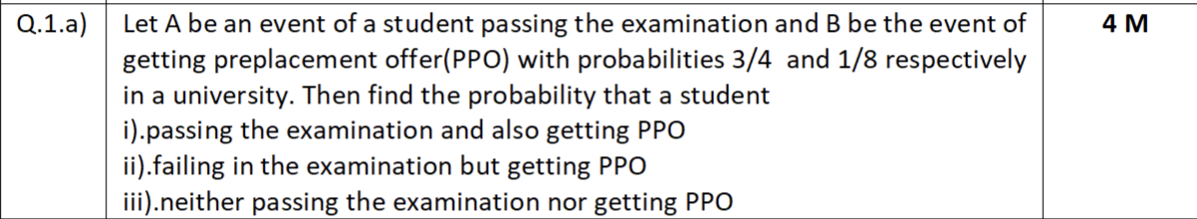

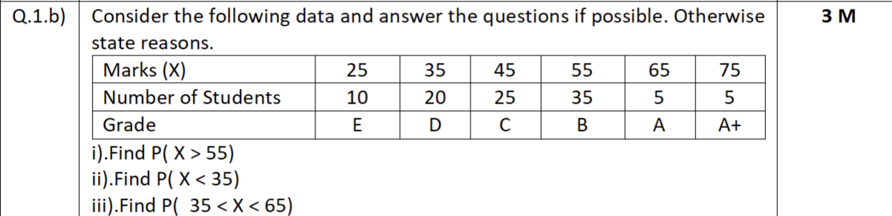

**2023-2024 (03rd Feb 2024) MidSem (Makeup) (AI&ML)**



**2025-2026 (18th Jan 2025) MidSem (Regular) (AI&ML)**

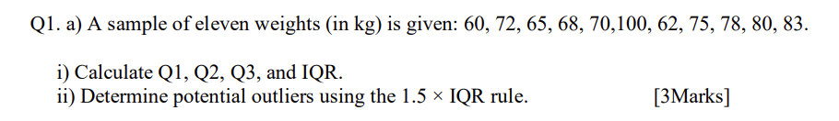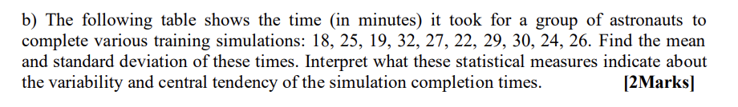

**2024-2025 (28th Jun 2025) MidSem (Makeup) (AI&ML)**

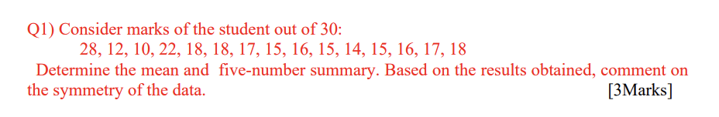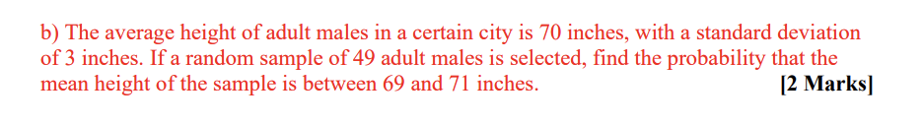

**Webinars**

## **CS 2 - Axioms of Probability, Mutually exclusive and independent events, Problem solving to understand basic probability concepts**

**Question Papers**

**2022-2023 (28th Jan 2023) MidSem (Makeup) (DSE)**

**Q1.**

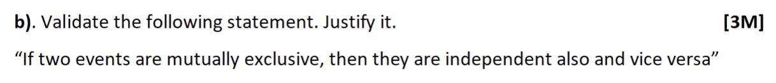

**2023-2024 (21st Jan 2024) MidSem (Regular) (AI&ML)**

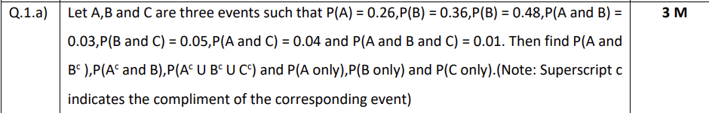



**2023-2024 (03rd Feb 2024) MidSem (Makeup) (AI&ML)**

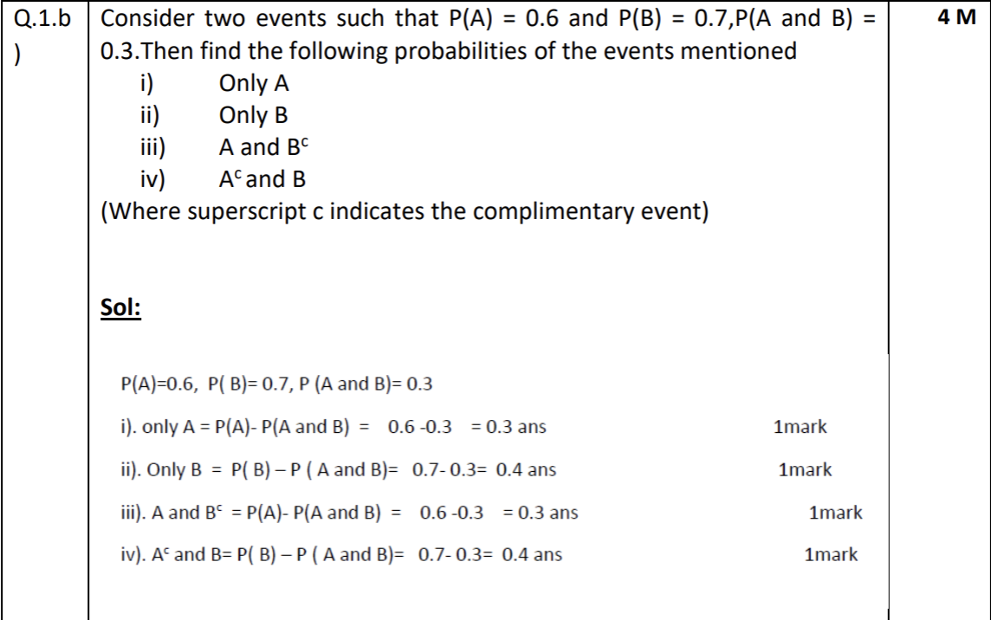

**Webinars**

# **Module 2: Conditional Probability & Bayes theorem**

## **CS 3 - Introduction to conditional probability, independent events, Total probability**

**Question Papers**

**2022-2023 (28th Jan 2023) MidSem (Makeup) (DSE)**

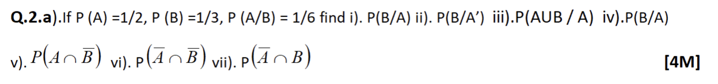

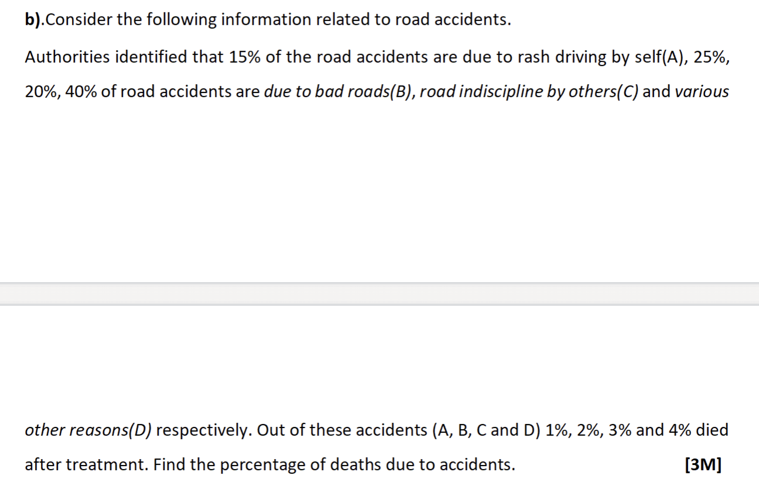



**2022-2023 (8th Jan 2023) MidSem (Regular) (DSE)**

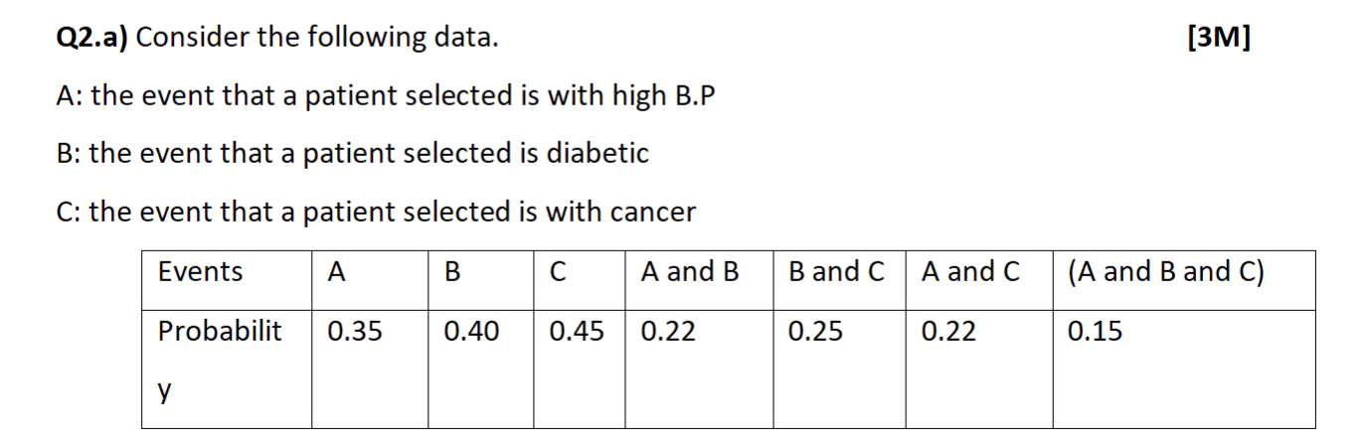

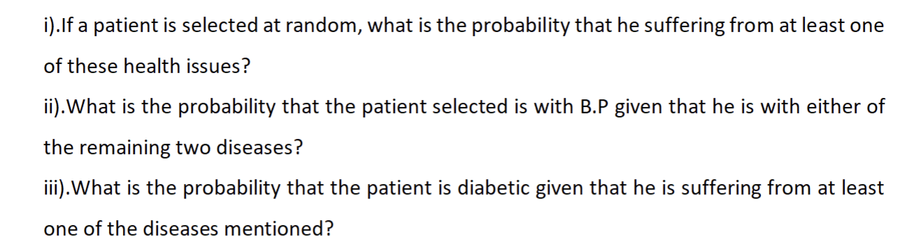

**2022-2023 (16th July 2023) MidSem (Regular) (AI&ML)**

**2022-2023 (02nd April 2023) EndSem (Regular) (DSE)**

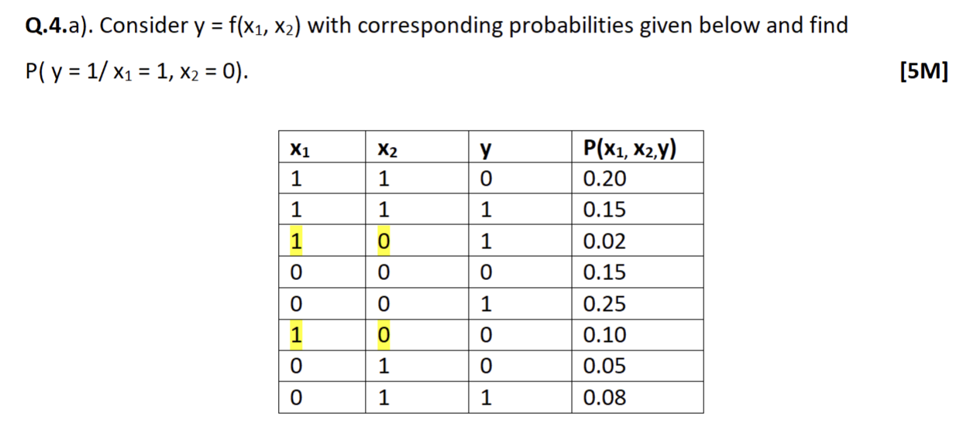

**2022-2023 (15th April 2023) EndSem (Makeup) (DSE)**

**Q4.**

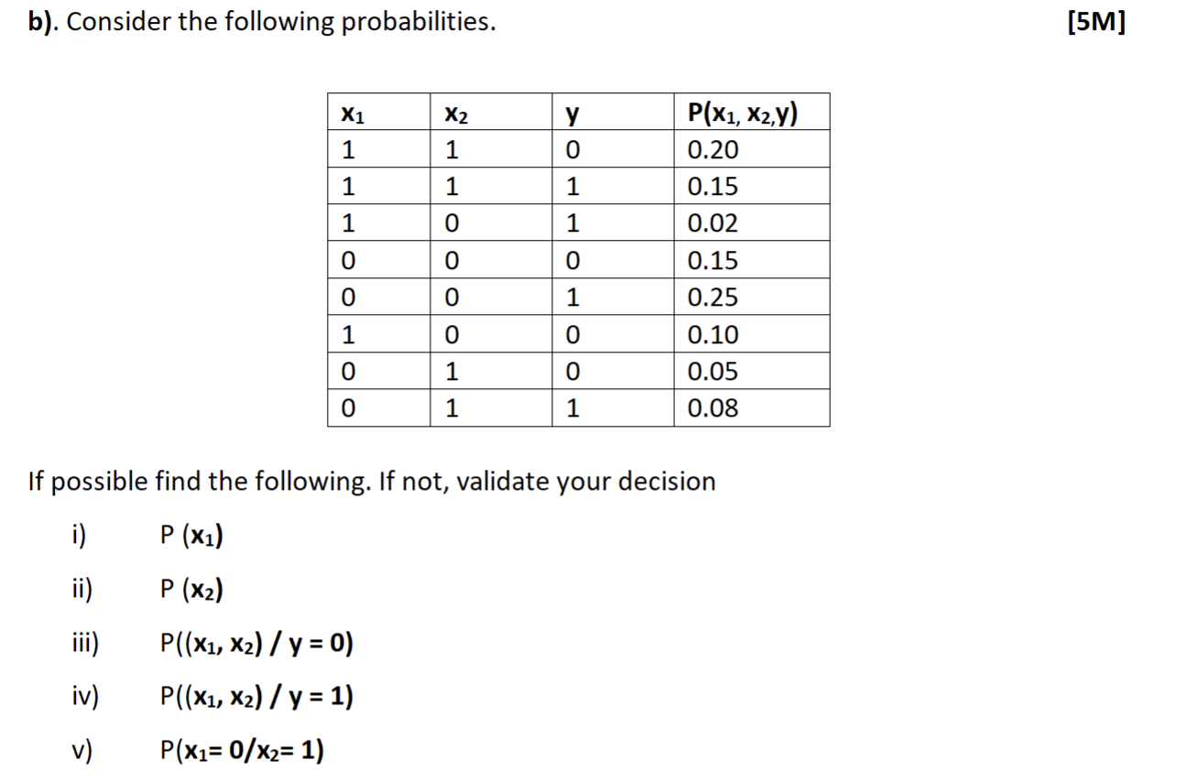

**2023-2024 (21st Jan 2024) MidSem (Regular) (AI&ML)**



**2023-2024 (03rd Feb 2024) MidSem (Makeup) (AI&ML)**

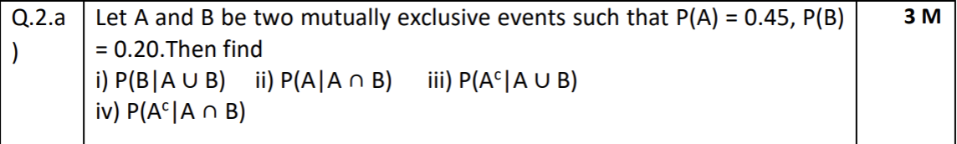

**Webinars**

## **CS 4 - Bayes theorem(with proof), Introduction to Naive Bayes concept.**

**Question Papers**

**2022-2023 (8th Jan 2023) MidSem (Regular) (DSE)**

**Q2.**

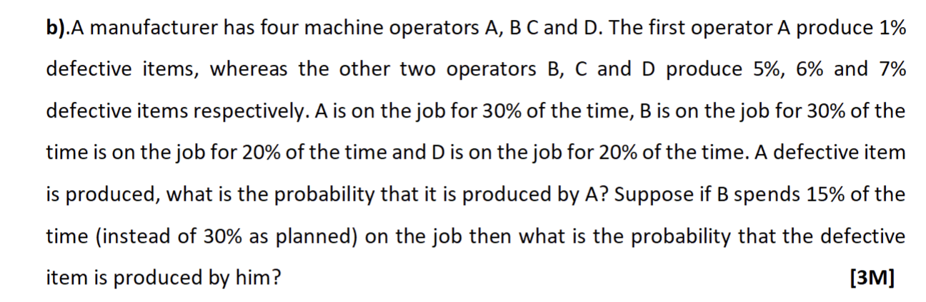

**2022-2023 (16th July 2023) MidSem (Regular) (AI&ML)**

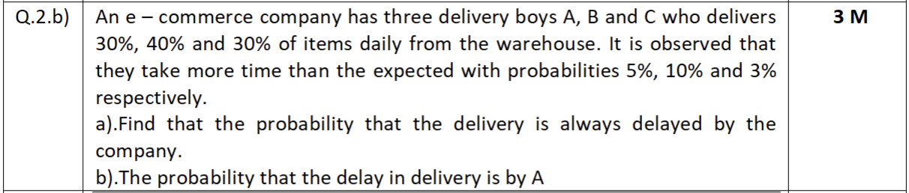

**2023-2024 (21st Jan 2024) MidSem (Regular) (AI&ML)**

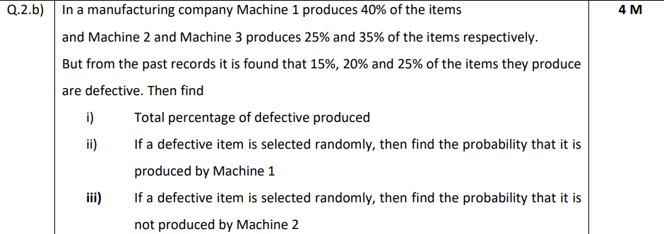

**2023-2024 (03rd Feb 2024) MidSem (Makeup) (AI&ML)**

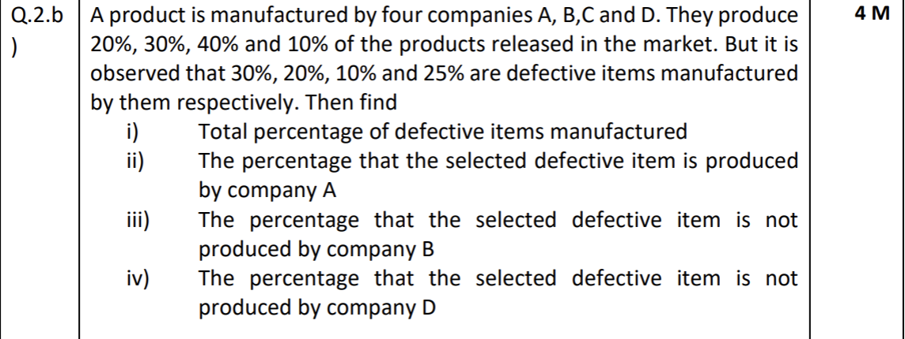

**2025-2026 (18th Jan 2025) MidSem (Regular) (AI&ML)**

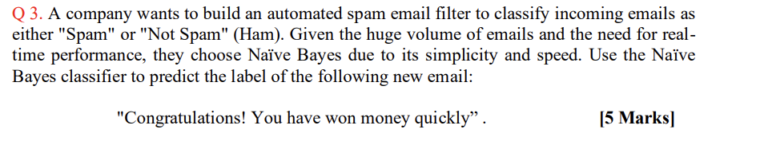

**2025-2026 (18th Jan 2025) MidSem (Regular) (AI&ML)**

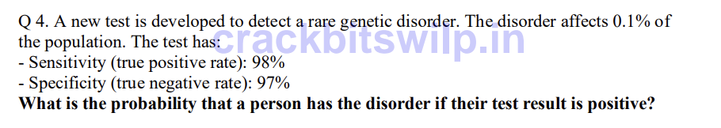

**2024-2025 (28th Jun 2025) MidSem (Makeup) (AI&ML)**

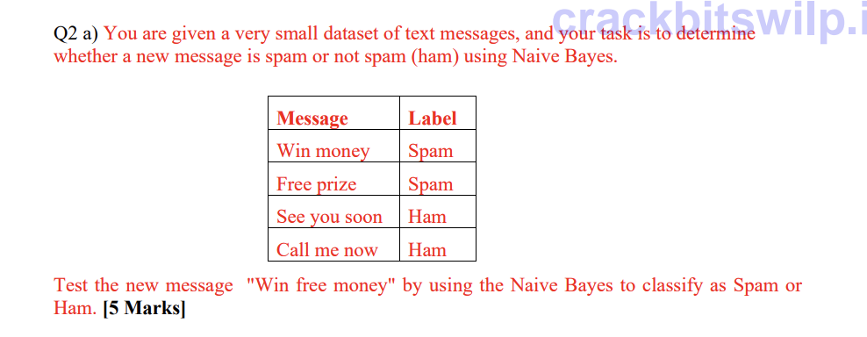

**2024-2025 (28th Jun 2025) MidSem (Makeup) (AI&ML)**

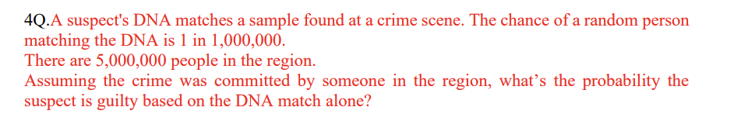

**Webinars**

# **Module 3: Probability Distributions**

## **CS 5 - Random variables - Discrete & continuous, Expectation of a random variable, mean and variance of a random variable - Single random, random variable & Joint distributions**

**Question Papers**

**2022-2023 (28th Jan 2023) MidSem (Makeup) (DSE)**

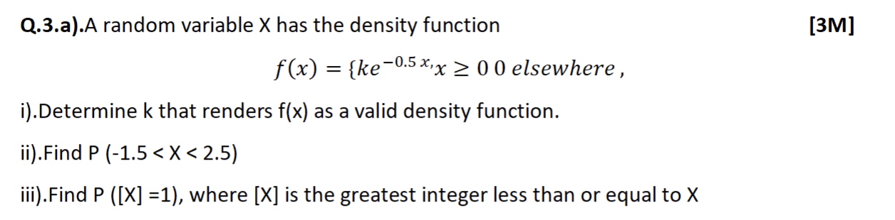

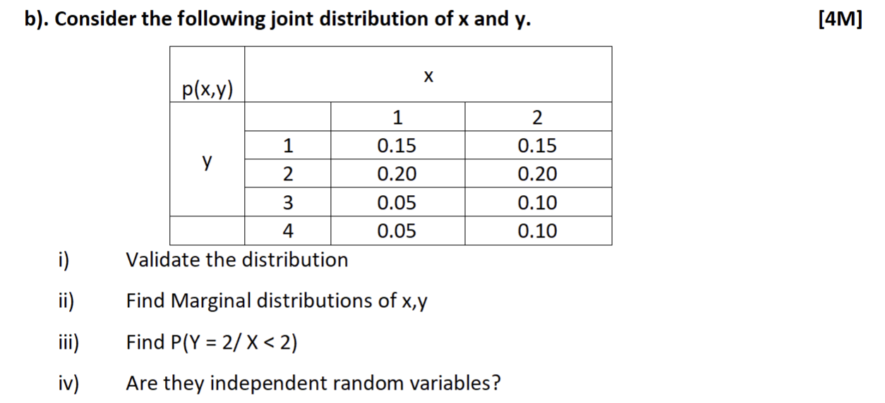

**2022-2023 (8th Jan 2023) MidSem (Regular) (DSE)**

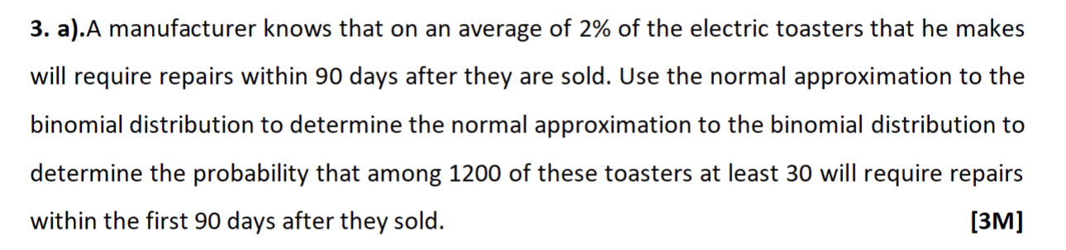

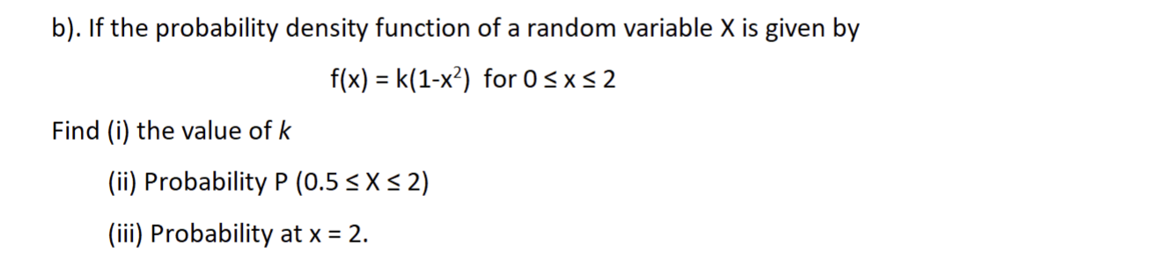

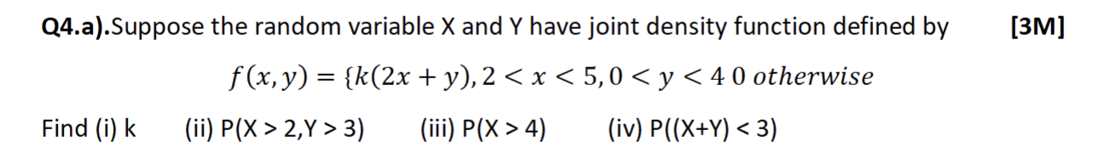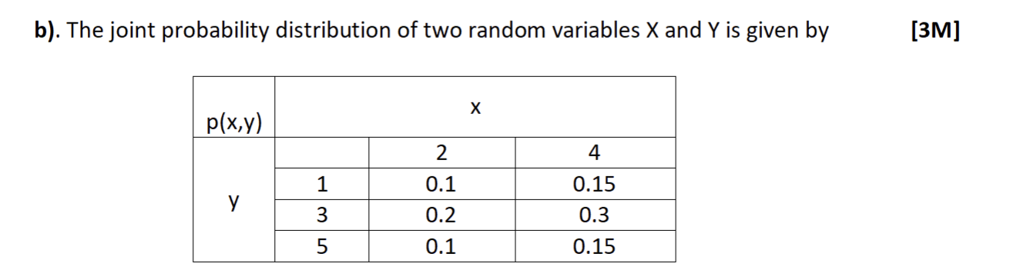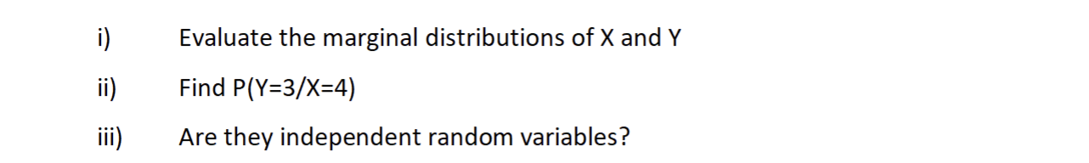

**2022-2023 (16th July 2023) MidSem (Regular) (AI&ML)**

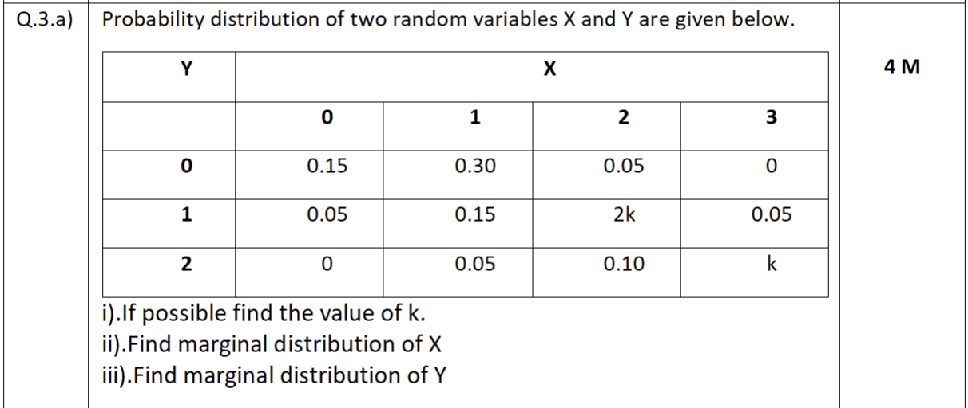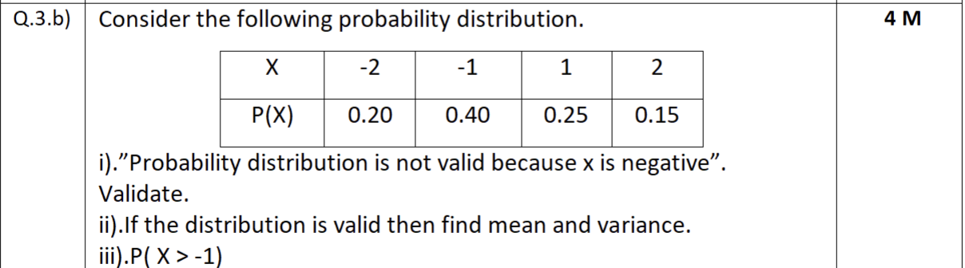

**2023-2024 (21st Jan 2024) MidSem (Regular) (AI&ML)**

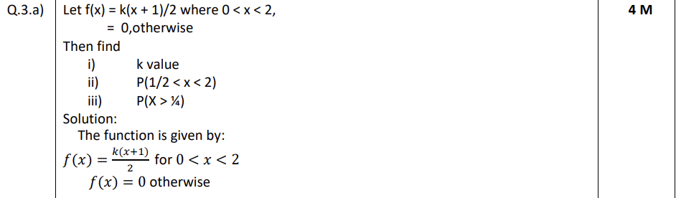

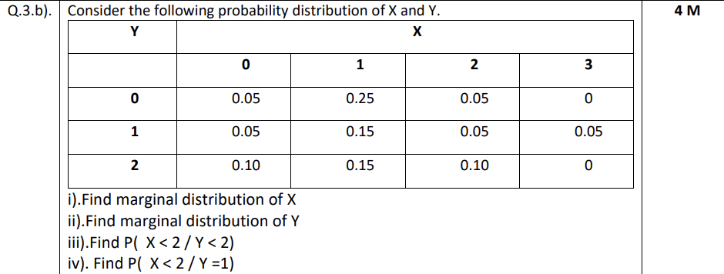

**2023-2024 (03rd Feb 2024) MidSem (Makeup) (AI&ML)**

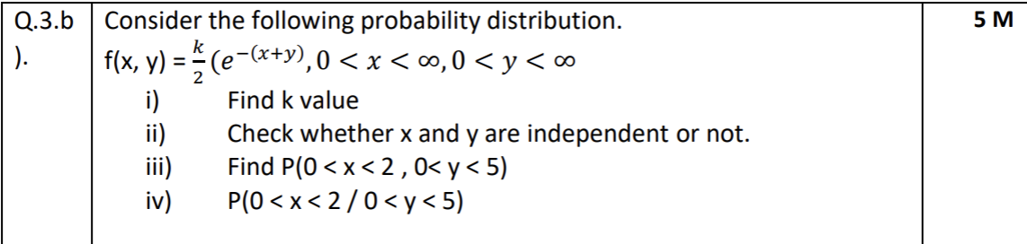

**2023-2024 (Apr 2024) EndSem (Regular) (AI&ML)**

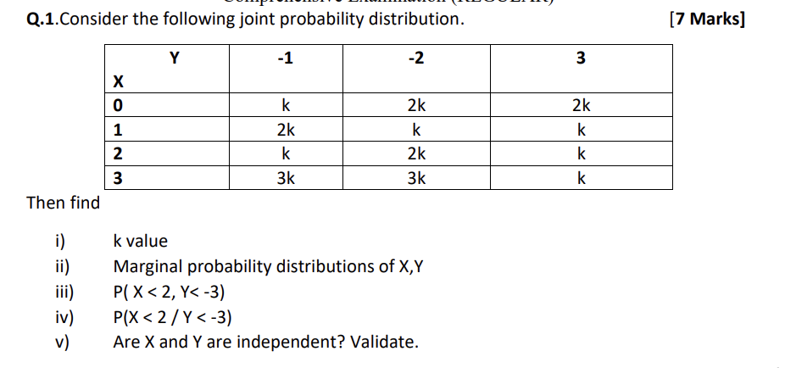

**2023-2024 (April 2024) EndSem (Makeup) (AI&ML)**

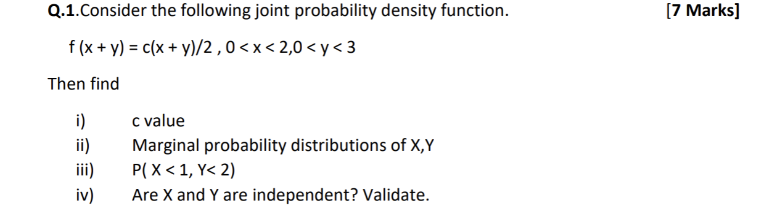

**2025-2026 (18th Jan 2025) MidSem (Regular) (AI&ML)**

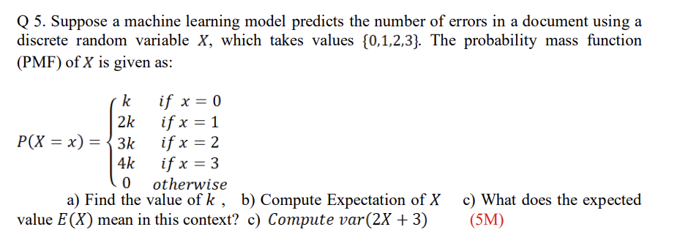

**2025-2026 (18th Jan 2025) MidSem (Regular) (AI&ML)**

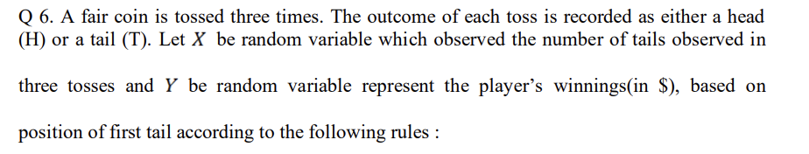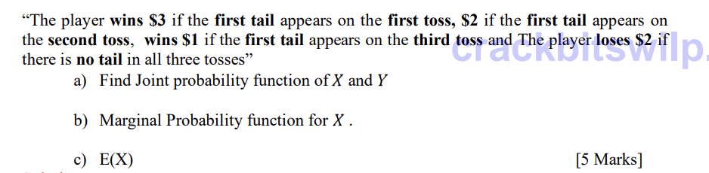

**2024-2025 (28th Jun 2025) MidSem (Makeup) (AI&ML)**

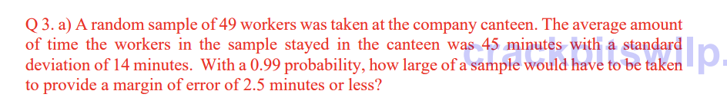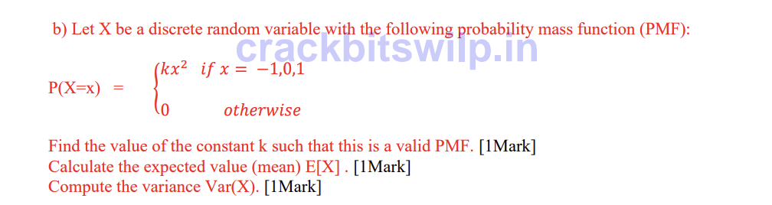

**2024-2025 (28th Jun 2025) MidSem (Makeup) (AI&ML)**

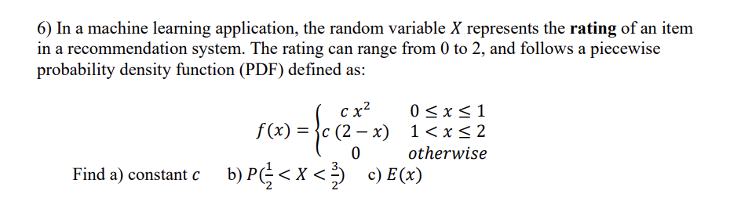

**Webinars**

## **CS 6 - Bernoulli, Binomial, Poisson and Normal distributions. Introduction to t - distribution , F - Distribution and Chi Square distributions**

**Question Papers**

**2022-2023 (28th Jan 2023) MidSem (Makeup) (DSE)**



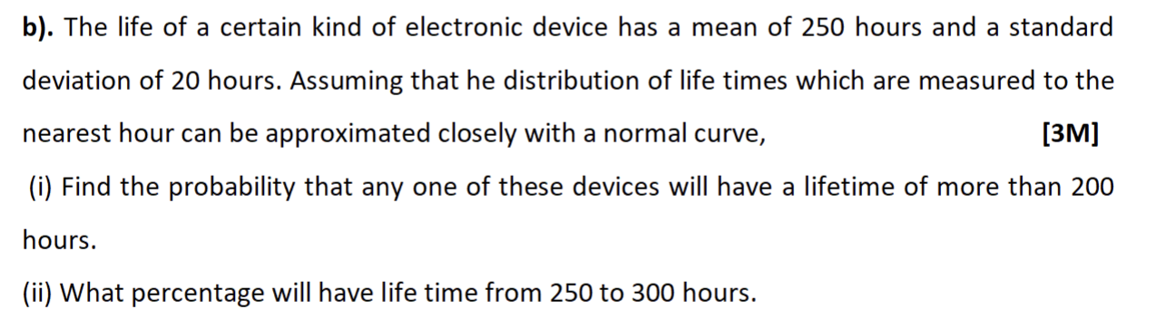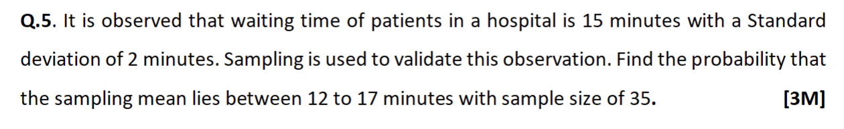

**2022-2023 (8th Jan 2023) MidSem (Regular) (DSE)**

**Q1.**



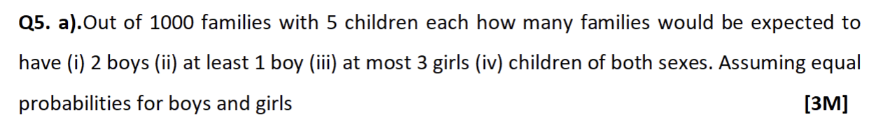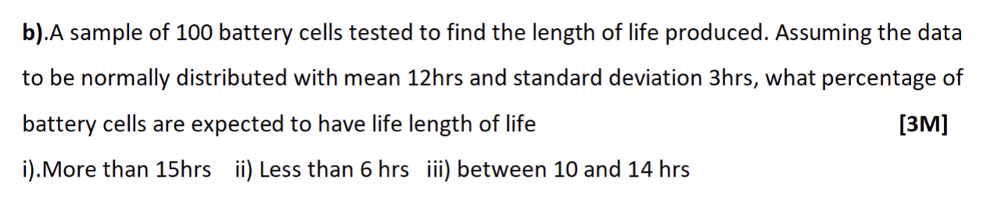

**2022-2023 (16th July 2023) MidSem (Regular) (AI&ML)**

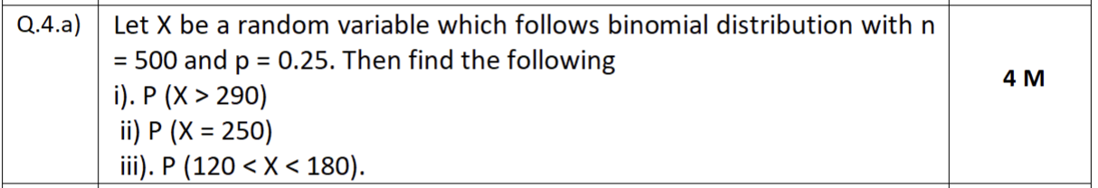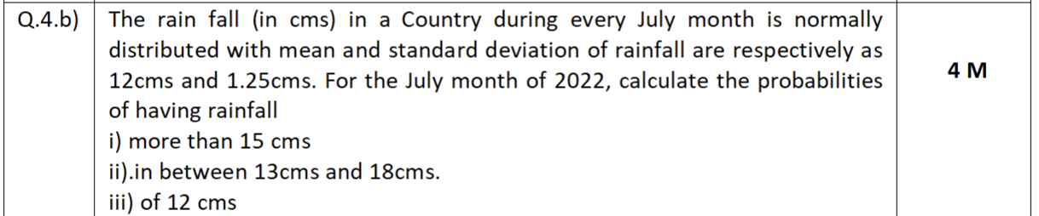

**2022-2023 (02nd April 2023) EndSem (Regular) (DSE)**

**Q3.**

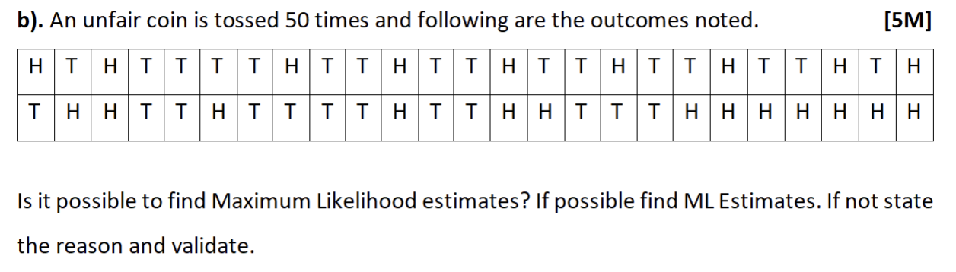

**2022-2023 (15th April 2023) EndSem (Makeup) (DSE)**



**2023-2024 (21st Jan 2024) MidSem (Regular) (AI&ML)**

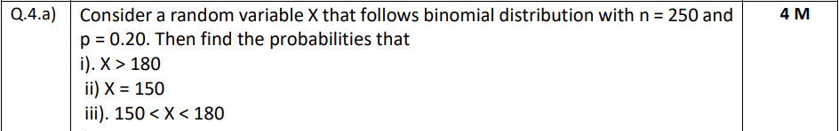

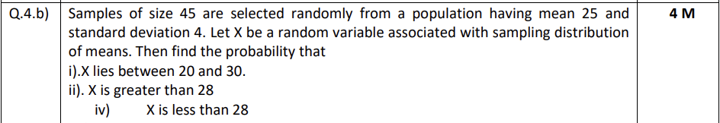

**2023-2024 (03rd Feb 2024) MidSem (Makeup) (AI&ML)**

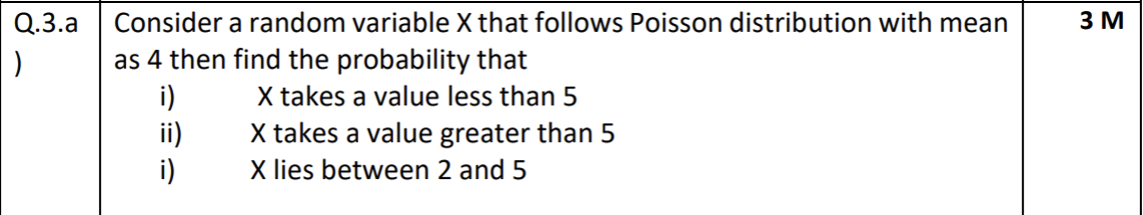

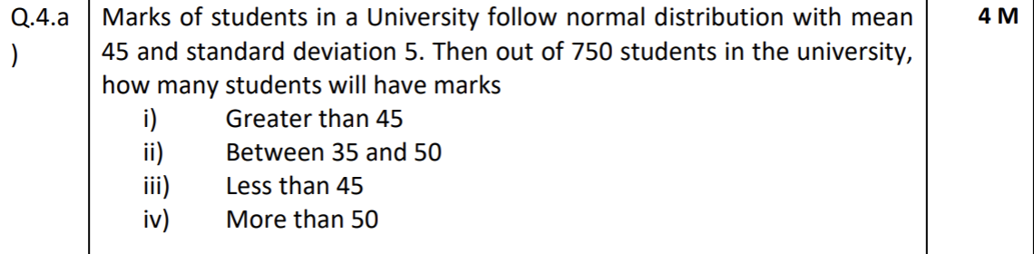

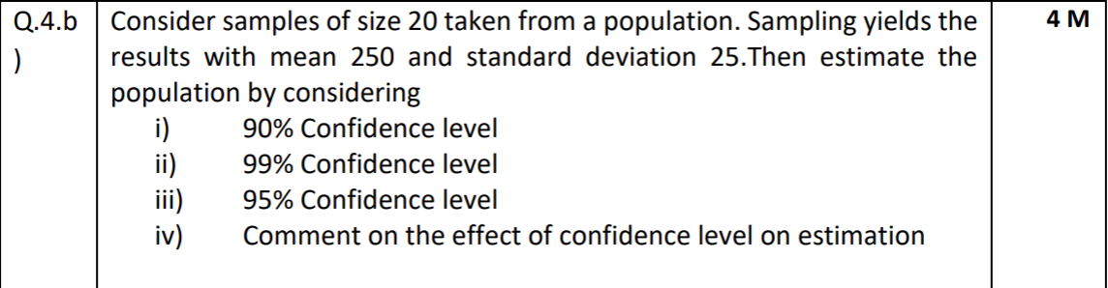

**2025-2026 EndSem (Regular) (AI&ML)**

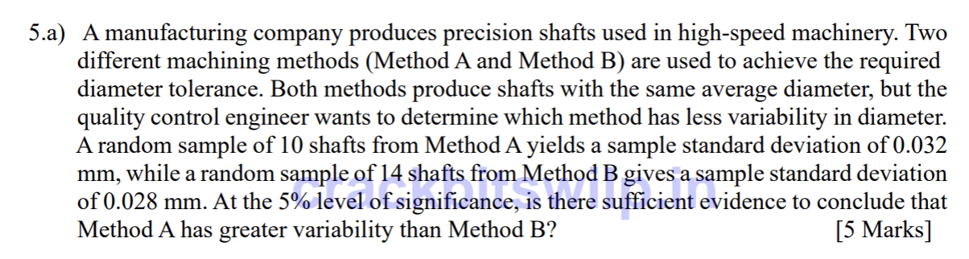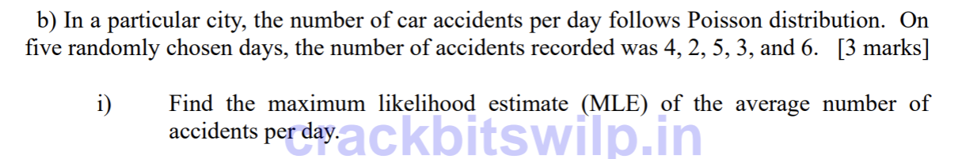

**2025-2026 (13th Sept 2025) EndSem (Makeup) (AI&ML)**

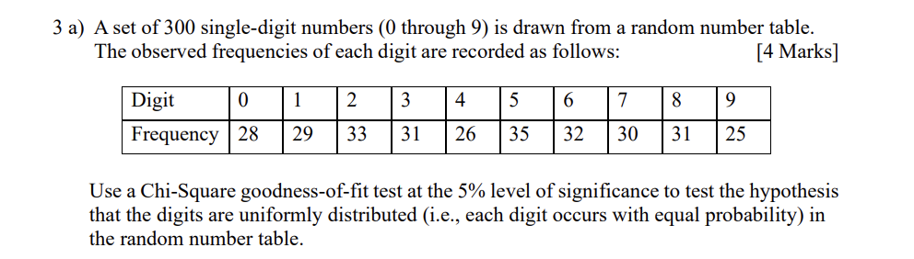

**2023-2024 (April 2024) EndSem (Makeup) (AI&ML)**

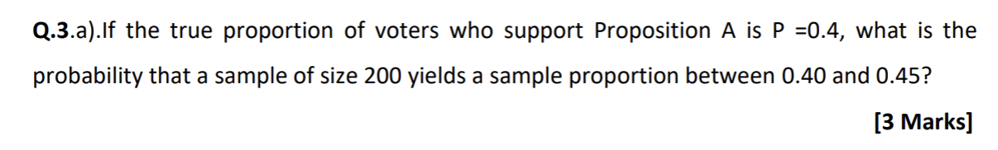

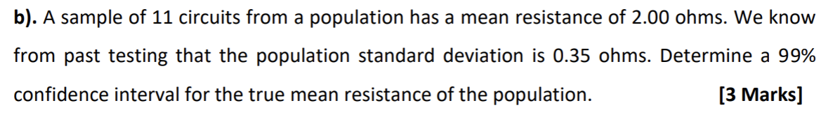

**2025-2026 (18th Jan 2025) MidSem (Regular) (AI&ML)**

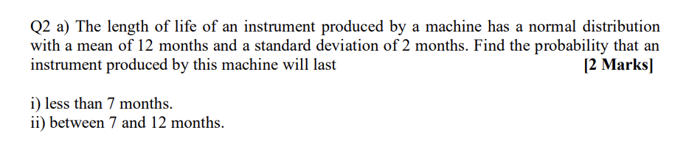

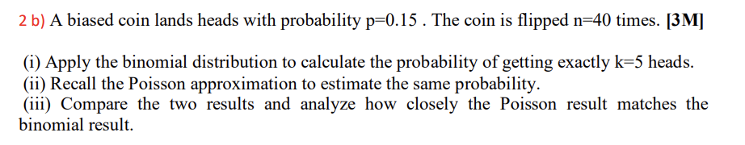

**2024-2025 (28th Jun 2025) MidSem (Makeup) (AI&ML)**

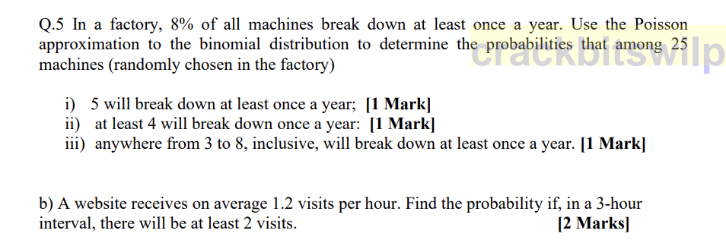

**Webinars**

Answers

**ISM - EC2 - MidSem**

# **Module 1: Basic Probability & Statistics**

## **CS 1 - Measures of Central Tendency & Measures of Variability, Data – Symmetric & Asymmetric, outlier detection, 5 point summary, Introduction to probability**

**Question Papers**

**2022-2023 (28th Jan 2023) MidSem (Makeup) (DSE)**



**Important Observations from the Summary:**

**1. Presence of Outliers**

* Several features have a very large gap between minimum and maximum values, e.g.:
  + compression_ratio: ranges from 7.0 -> 23.0
  + horsepower: 48 -> 288
  + engine_size: 61 -> 326
  + curb_weight: 1488 -> 4066

Such wide ranges compared to their means/std indicate **possible outliers**, which must be detected and handled during preprocessing.

**2. Features Are on Different Scales (Normalization/Standardization Required)**

The summary shows large variation in magnitude:

* curb_weight = 2555
* engine_size = 127
* bore = 3.3
* city_mpg = 25
* symboling = 0.83

Since the scales differ drastically, algorithms like KNN, SVM, logistic regression, and neural networks will require normalization or standardization.

**3. No Missing Values**

Every column shows:

* count = 205

This means the dataset has no missing values for these attributes, so imputation is not required, and the dataset is clean in this regard.

**4. Skewness in Various Attributes**

Some attributes have a noticeable difference between mean (average) and 50% percentile (median):

* horsepower: mean = 104.16, median = 95 -> right-skewed
* engine_size: mean = 126.9, median = 120 -> right-skewed
* curb_weight: mean = 2555, median = 2414 -> right-skewed

Such skewness indicates that:

* Data transformation (log, Box-Cox) to normalize distribution might improve model performance.
* Outlier or high-value observations are pulling the mean upward.

**2022-2023 (8th Jan 2023) MidSem (Regular) (DSE)**



**2022-2023 (16th July 2023) MidSem (Regular) (AI&ML)**





**2023-2024 (03rd Feb 2024) MidSem (Makeup) (AI&ML)**



**2025-2026 (18th Jan 2025) MidSem (Regular) (AI&ML)**



**2024-2025 (28th Jun 2025) MidSem (Makeup) (AI&ML)**



**Webinars**

## **CS 2 - Axioms of Probability, Mutually exclusive and independent events, Problem solving to understand basic probability concepts**

**Question Papers**

**2022-2023 (28th Jan 2023) MidSem (Makeup) (DSE)**

**Q1.**



**Justification (The statement is FALSE)**

**1. Mutually Exclusive Definition**

* Two events A and B are **mutually exclusive** if:  
   P(A∩B)=0

**2. Independent Events Definition**

* Two events A and B are **independent** if:  
   P(A∩B)=P(A)⋅P(B)

**3. Why Mutually Exclusive Cannot Be Independent**

If events are mutually exclusive:

P(A∩B)=0

For them to be independent, we must also have:

0=P(A)⋅P(B)

This is possible only when at least one of the events has probability 0.

* If P(A)>0 and P(B)>0, then  
   P(A)⋅P(B)>0 but P(A∩B)=0 => Cannot be independent.

Thus, mutually exclusive events (with non-zero probability) are **always dependent**.

**4. Independence Does NOT Mean Mutually Exclusive**

If events are independent:

P(A∩B)=P(A)⋅P(B)

This value is greater than zero for non-zero probabilities, meaning the events can occur together -> So they **cannot be mutually exclusive**.

**Conclusion**

* Mutually exclusive events (with non-zero probability) are **not independent**.
* Independent events are **not mutually exclusive**.
* Therefore, the statement is **invalid**.

**2023-2024 (21st Jan 2024) MidSem (Regular) (AI&ML)**





**2023-2024 (03rd Feb 2024) MidSem (Makeup) (AI&ML)**



**Webinars**

# **Module 2: Conditional Probability & Bayes theorem**

## **CS 3 - Introduction to conditional probability, independent events, Total probability**

**Question Papers**

**2022-2023 (28th Jan 2023) MidSem (Makeup) (DSE)**



P(A)=1/2, P(B)=1/3, P(A/B)=1/6

P(A∩B) = P(A/B)⋅P(B) = 1/6×1/3 = 1/18

1. **P(B/A)**

P(B/A) = P(A∩B)/P(A) = (1/18) / (1/2) = 1/9

1. **P(B/A′)**

P(B/A′) = P(B∩A′)⋅P(A′) = P(B)-P(A∩B) / 1−P(A) = (1/3 - 1/18) / (1 - 1/2) = 5/9

1. **P(A**⋃**B/A)**  
   Since A⊆A⋃B, given A the union certainly occurs:  
   P(A⋃B/A) = 1​

Also by formula, P(A⋃B/A) = P((A⋃B)∩A)/P(A) = P(A)/P(A) = 1

1. **P(B/A)**  
    (This Question is the same as part (i).)
2. **P(A∩B′)**

P(A∩B′) = P(A)-P(A∩B) = 1/2 - 1/18 = 4/9

1. **P(A′∩B′)**

P(A′∩B′) = 1-P(A⋃B) = 1-(P(A)+P(B)-P(A∩B))=1-(1/2​+1/3​-1/18​)=2/9​.

1. **P(A′∩B)**

P(A′∩B) = P(B)-P(A∩B) = 5/18





Given: Causes of road accidents

P(A) = Rash driving by self (A) = 15%

P(B) = Bad roads (B) = 25%

P(C) = Road indiscipline by others (C) = 20%

P(D) = Other reasons (D) = 40%

Death rates after these accidents:

P(S/A) -> 1%

P(S/B) → 2%

P(S/C) → 3%

P(S/D) → 4%

By Law of Total Probability,

P(S) = P(A)P(S/A)+P(B)P(S/B)+P(C)P(S/C)+P(D)P(S/D)

P(S) = (0.15×0.01) + (0.25×0.02) + (0.20×0.03) + (0.40×0.04)

P(S) = 0.0285 = 2.85%

**2022-2023 (8th Jan 2023) MidSem (Regular) (DSE)**





**2022-2023 (16th July 2023) MidSem (Regular) (AI&ML)**



**2022-2023 (02nd April 2023) EndSem (Regular) (DSE)**



**2022-2023 (15th April 2023) EndSem (Makeup) (DSE)**

**Q4.**



**2023-2024 (21st Jan 2024) MidSem (Regular) (AI&ML)**



**2023-2024 (03rd Feb 2024) MidSem (Makeup) (AI&ML)**



**2023-2024 (April 2024) EndSem (Makeup) (AI&ML)**



**Webinars**

## **CS 4 - Bayes theorem(with proof), Introduction to Naive Bayes concept.**

**Question Papers**

**2022-2023 (8th Jan 2023) MidSem (Regular) (DSE)**

**Q2.**



**2022-2023 (16th July 2023) MidSem (Regular) (AI&ML)**



**2023-2024 (21st Jan 2024) MidSem (Regular) (AI&ML)**



**2023-2024 (03rd Feb 2024) MidSem (Makeup) (AI&ML)**



**2025-2026 (18th Jan 2025) MidSem (Regular) (AI&ML)**



**2025-2026 (18th Jan 2025) MidSem (Regular) (AI&ML)**



**2024-2025 (28th Jun 2025) MidSem (Makeup) (AI&ML)**



**2024-2025 (28th Jun 2025) MidSem (Makeup) (AI&ML)**



**Webinars**

# **Module 3: Probability Distributions**

## **CS 5 - Random variables - Discrete & continuous, Expectation of a random variable, mean and variance of a random variable - Single random, random variable & Joint distributions**

**Question Papers**

**2022-2023 (28th Jan 2023) MidSem (Makeup) (DSE)**





**2022-2023 (8th Jan 2023) MidSem (Regular) (DSE)**







**2022-2023 (16th July 2023) MidSem (Regular) (AI&ML)**



**2023-2024 (21st Jan 2024) MidSem (Regular) (AI&ML)**





**2023-2024 (03rd Feb 2024) MidSem (Makeup) (AI&ML)**



**2023-2024 (Apr 2024) EndSem (Regular) (AI&ML)**



**2025-2026 (18th Jan 2025) MidSem (Regular) (AI&ML)**



**2025-2026 (18th Jan 2025) MidSem (Regular) (AI&ML)**



**2024-2025 (28th Jun 2025) MidSem (Makeup) (AI&ML)**



**2024-2025 (28th Jun 2025) MidSem (Makeup) (AI&ML)**



**Webinars**

## **CS 6 - Bernoulli, Binomial, Poisson and Normal distributions. Introduction to t - distribution , F - Distribution and Chi Square distributions**

**Question Papers**

**2022-2023 (28th Jan 2023) MidSem (Makeup) (DSE)**





**2022-2023 (8th Jan 2023) MidSem (Regular) (DSE)**

**Q1.**





**2022-2023 (16th July 2023) MidSem (Regular) (AI&ML)**



**2022-2023 (02nd April 2023) EndSem (Regular) (DSE)**

**Q3.**



**2022-2023 (15th April 2023) EndSem (Makeup) (DSE)**



**2023-2024 (21st Jan 2024) MidSem (Regular) (AI&ML)**



**2023-2024 (03rd Feb 2024) MidSem (Makeup) (AI&ML)**







**2025-2026 EndSem (Regular) (AI&ML)**



**2025-2026 (13th Sept 2025) EndSem (Makeup) (AI&ML)**



**2023-2024 (April 2024) EndSem (Makeup) (AI&ML)**





**2025-2026 (18th Jan 2025) MidSem (Regular) (AI&ML)**





**2024-2025 (28th Jun 2025) MidSem (Makeup) (AI&ML)**



**Webinars**